Math 1020 (Medical Math) Name: ________________
Measurement and Medicine
A patient weighs 68 lb and is 4 ft 7 in tall.
A doctor has written a prescription that states: CeeNU 18 mg/m²/day PO.
The drug label states: CeeNU 10 mg/capsule and max: 0.13 g/m²/day.

- Determine that the ordered amount is NOT an overdose:
  - What is the maximum dosage that the label gives?

  - The prescription is in units of mg, and the drug label max dosage is in units of g. In order to compare the ordered amount with the maximum dosage, we must use the same unit of measurement. Convert 18 mg to g while showing your work:

  - Compare the prescribed dosage (found in #1b) with the maximum dosage (found in #1a). Is it an overdose?

If it is not an overdose, how many grams less than the maximum dosage is the prescribed dosage? (Show your work).

- Since the prescribed amount is in terms of mg per square meter per day, we must know the patient’s body surface area (BSA) first before calculating the amount of drug to give.
  - First find the BSA using the given Nomogram:
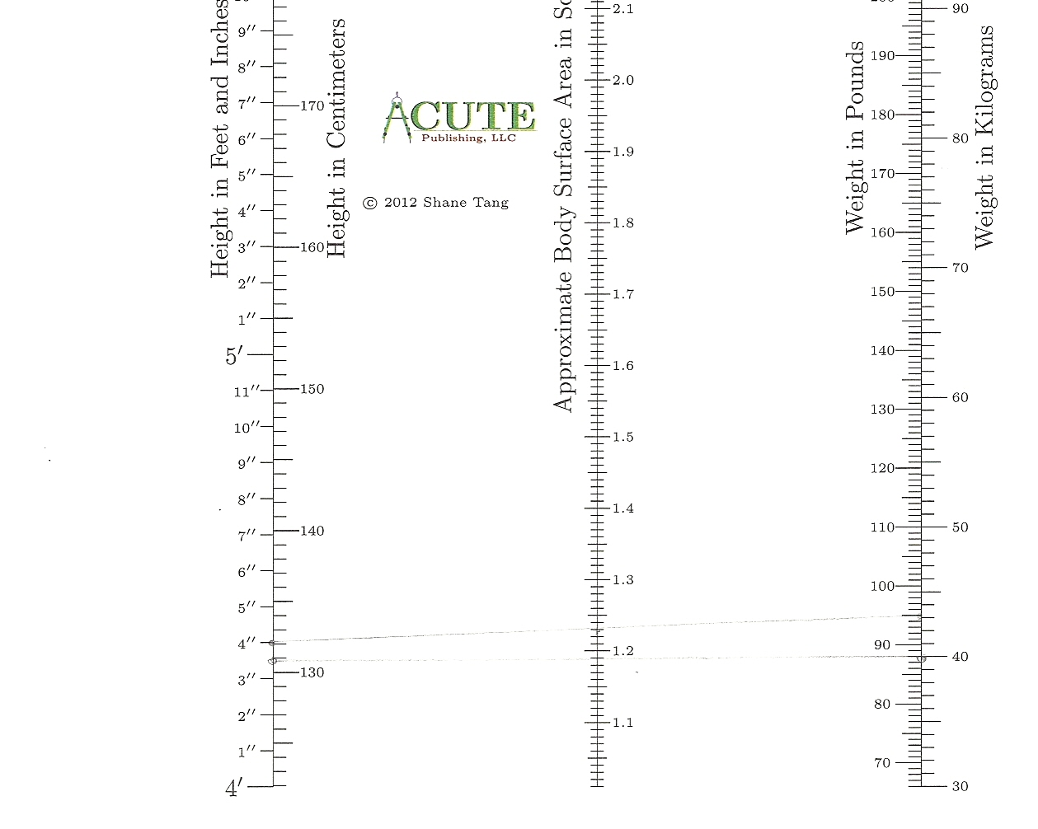

$BSA= \sqrt{\frac{np}{3131}}$ m²
  - Now find the BSA using the given formula
where n=inches and p=pounds. (Show your work and round to two decimal places.) *Note: It is ok if the BSA is different from #2a. This is because we are using a different method.

- Now that we know the BSA (for the rest of the steps we will use the BSA obtained from the formula in #2b), we can finally calculate how much drug we should give to our patient per day.
  - What is the prescribed amount of drug to give?

  - Using both the prescribed amount (found in #3a) and the BSA of your patient (found in #2b), calculate how many mg per day should be given to your patient. (Remember to show your work and round to two decimal places).

  - What is the strength of the drug as given on the label? From the information, form two fractions, each of which is equivalent to 1.

  - Using the prescribed amount of mg per day (found in #3b) and the strength of the drug (one of the fractions from #3c), calculate the amount of drug you need to give your patient per day. (Show your work and round to the nearest whole number).

- Reflection:
What problems did you encounter as you completed this problem and how did you troubleshoot them? What skills did you improve by doing this problem? Reflect on how you thought about medicine and measurement before and after this chapter. Have any of your assumptions or understandings changed?

